Vehicle to Grid (V2G) Smart Grid for Power Overload with Grid Network

Timothy Rampiaray   
Department of ECE UCF  
tarampia@knights.ucf.edu  
Assignment1

*Abstract*—The demand for power within grid system’s due to the rise in battery electric vehicles (BEVs), plug-in battery electric vehicles (PHEVs), and extended range electric vehicles (EREVs). This paper looks at the dynamic state of a 33 Bus network over a 24-hour period of 1800 vehicles. A control algorithm will be hypothesized to dynamically control price at certain areas of the bus network during high load times.

# Introduction

In a liberalized market, players will need to change their strategies and how the act upon the new energy demands that will be required in a grid. In Power Systems (PS) there are many resources available that will have to be managed appropriately. These resources include Demand Response (DR), Renewable Energy (RE), Distributed Generation (DG) and systems of storage have been gaining traction.

A prominent replacement for the Internal Combustion Engine is Electric Vehicles (EV). The advantage of EVs is there ability to reduce overall CO2 emissions. In the Vehicle-to-Grid (V2G) concept EVs can be used. The optimization of a grid with some many different factors and the multitude of energy resources can turn into a large combinatorial problem.

For the given simulated network bus an algorithm will be developed to simulate the dynamic price change at specific bus network points for EVs to charge

.

# Case study

## 33-Bus Network

The 33-Bus Network [1], will have elements such as Waste to Energy, Photovoltaic, Biomass, Fuel Cell, Hydro, Wind and Cogeneration. This replicates a configuration of a network that may be seen in the year 2040 (*Figure 1.*). The peak load for this 33-Bus MV sized network is 4.36 MVA.

VEHICLE 
CLASS 
DESCRIPTION 
• wneets. with a rnaximum 
mass Of 400kg or 550kg for a 
vehicle (not irau&ng the of 
the batteries in an electrically gx:nvered 
vehicle) and a maximum Mt 
whatever of or of 
15kW 
vehicle. four wheels and up 8 
Seats in addition to the driver'S Wat_ 
vehicle. a 
maximum laden mass o' 
vehicle. a 
mass between 3,5Wkg and 
12,000kg. 
5: vehicle classes 

*Table 1. Vehicles used in simulation tests*

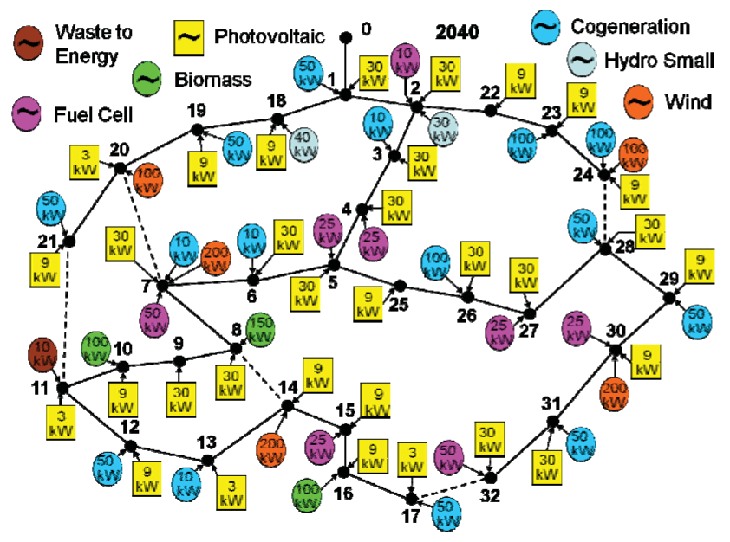

*Figure 1. Configuration of network in 2040*

## Data

The data consists of 1800 real world vehicles[2] (*Table 1.*) that would will be entering and leaving different locations on the bus network over a 24 hour period. The eights types of vehicle specs can be seen in the table below. (*Table 2.*) The simulated data for the 24-Hour period also contains the initial state of the battery capacity for all 1800 vehicles.

Table 1. EV battery specifications 
Battery capacity (kWh) 
Charging rates (kW) 
Vehicle class 
Ml 
BEV 
L7e 
Ml 
PHEV 
Ml 
EREV 
Max 
120 
15 
13.6 
13.6 
226 
226 
Mean 
29 
8.7 
8.2 
17 
17 
Min 
10 
51 
2.2 
12 
12 
Slow charge rate 
2-8.8 
1.3-3.3 
10 
1-3 
3-5.3 
3-5.3 
Fast charge rate 
3-240 
10-45 
35-60 
3—7.5 
11 
11 

*Table 1. Battery Capacity of vehicles used*

# Data preparation and visualization

The data for the vehicles within the network can be visualized for the 24-Hour period. The following figures represent the data for the four types of electric vehicles. Figures (2,4,6,8) represent the Current State of the Battery for specific EVs. The Figures (3,5,7,9) represent the various frequency of power discharges over the course of the 24-Hour period for the corresponding EVs.

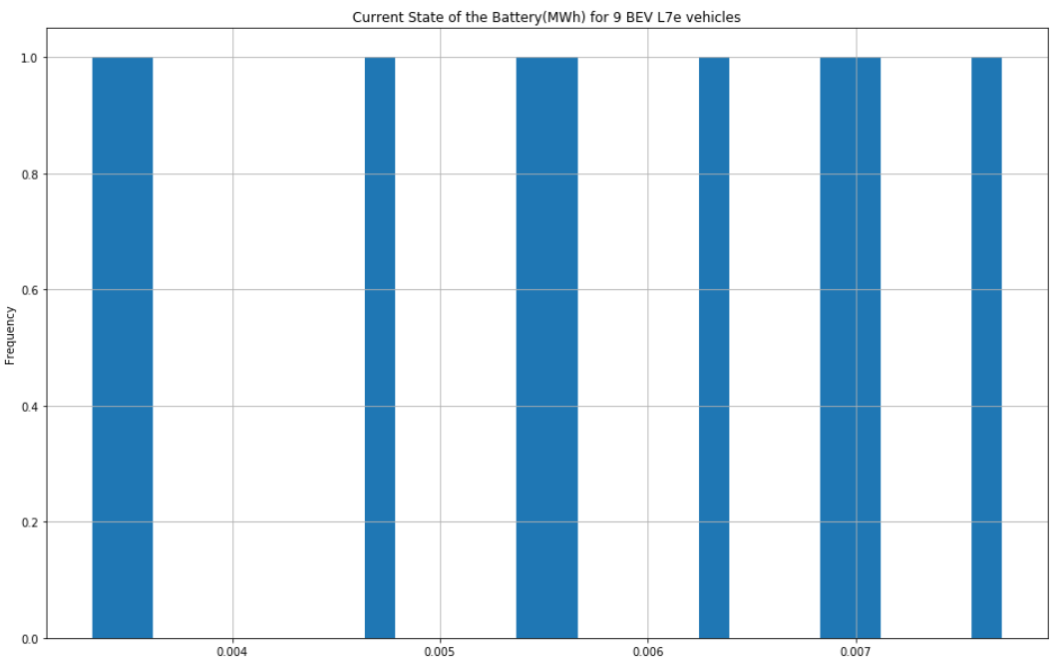

*Figure 2. Current State of Battery (MWh) for 9 BEV L7e*

*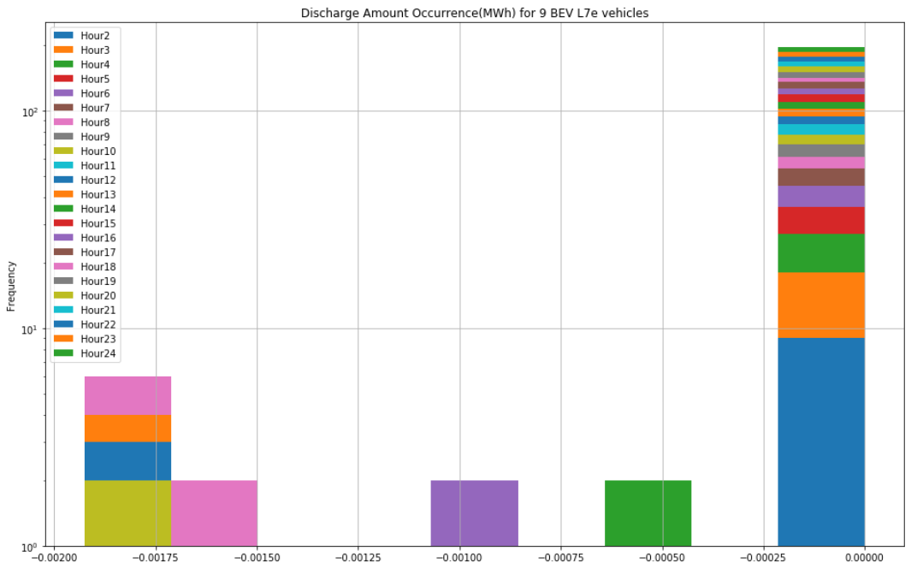*

*Figure 3. Battery (MWh) Discharge Amount Frequency for 9 BEV L7e*

*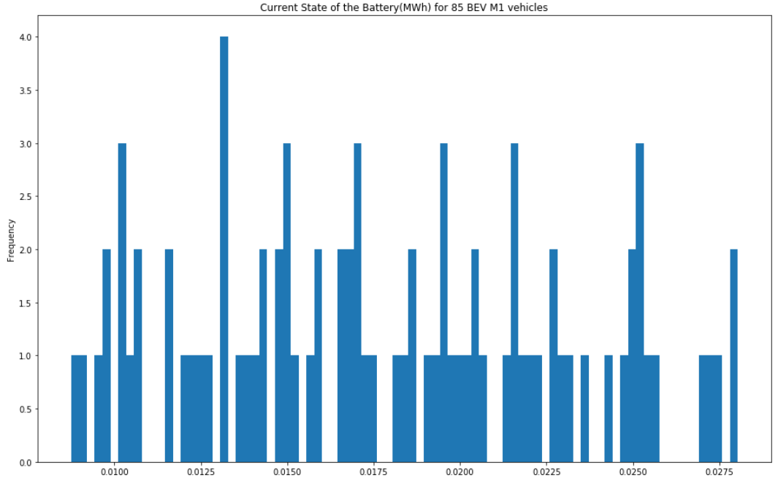*

*Figure 4. Current State of Battery (MWh) for 85 BEV M1*

*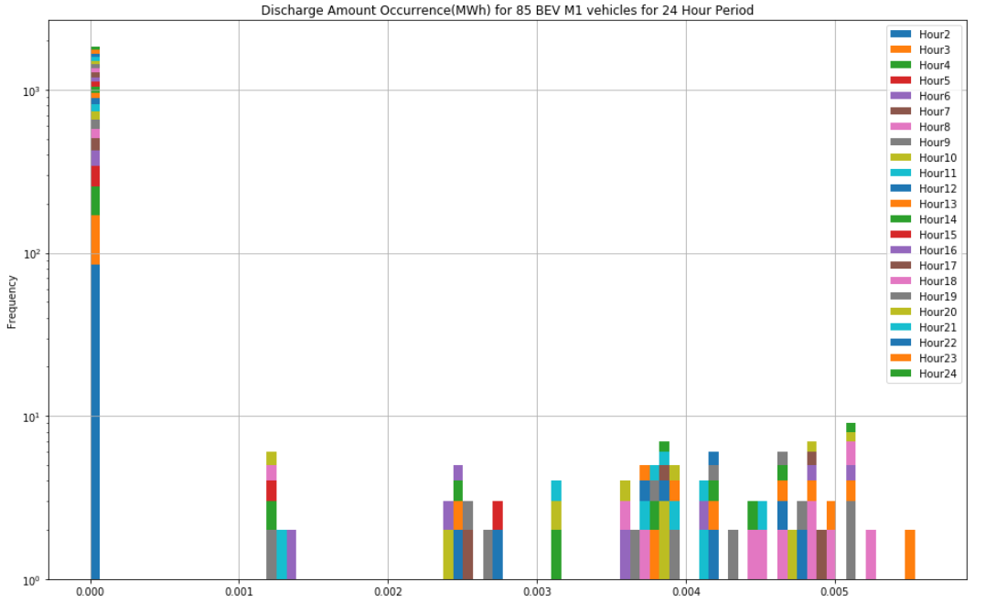*

*Figure 5. Battery (MWh) Discharge Amount Frequency for 85 BEV M1*

*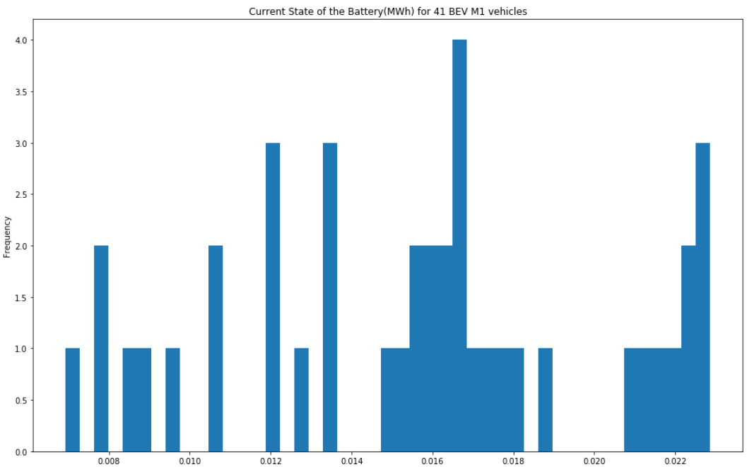*

*Figure 6. Current State of Battery (MWh) for 41 BEV M1*

*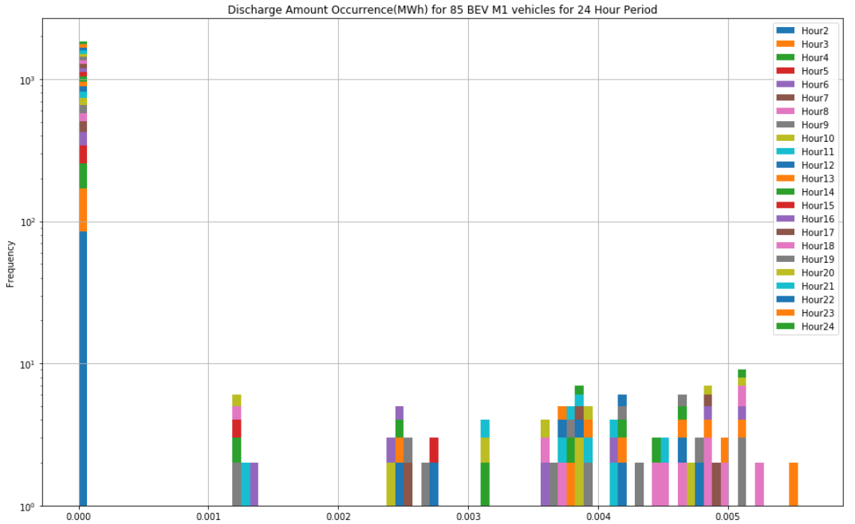*

*Figure 7. Battery (MWh) Discharge Amount Frequency for 85 BEV M1*

*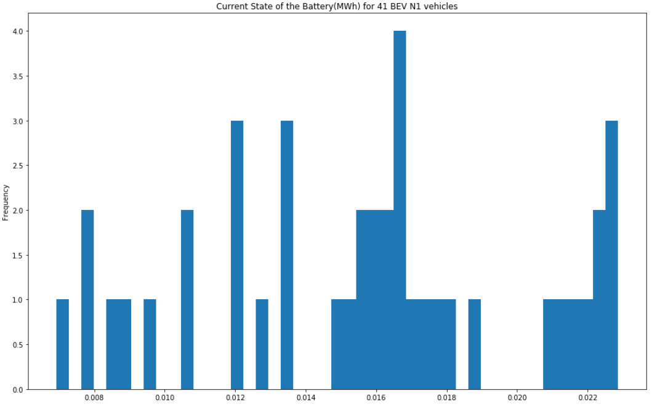*

*Figure 8. Current State of Battery (MWh) for 41 BEV N1*

*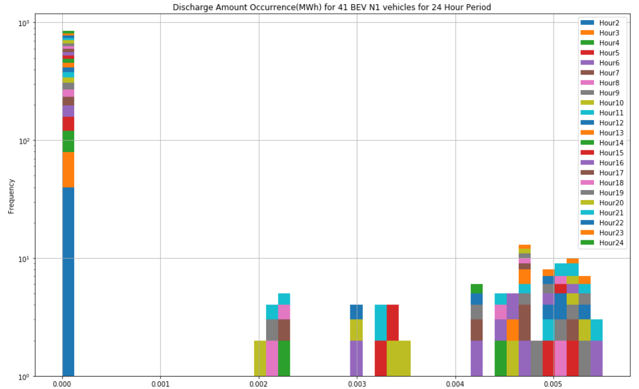*

*Figure 9. Battery (MWh) Discharge Amount Frequency for 41 BEV N1*

*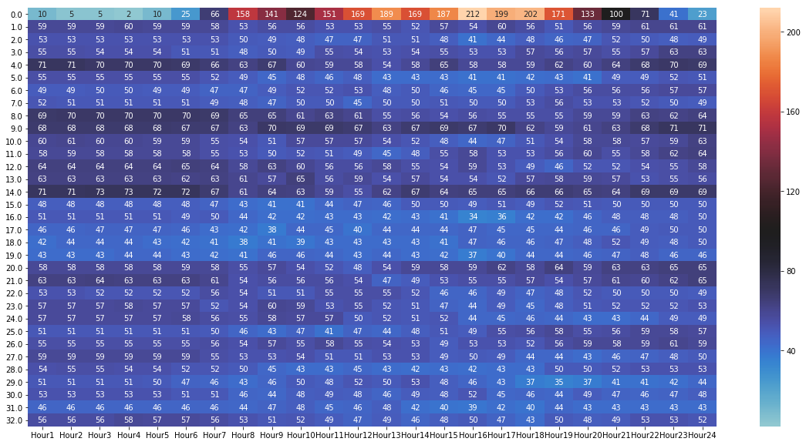*

*Figure 10. The frequency of vehicle discharges at a time period and point on the Bus.*

For example, as seen in *Figure 6.* The most common battery state for the BEV N1 vehicles was ~0.017MWh. Also, the most common discharge amount for the same vehicle was ~0.0045 MWh *Figure 7.* The heat map (*Figure 10.*) is seen as the most useful chart because it depicts where the most and least vehicles are drawing power from. For example, Bus 14 from Hour 1-6 shows high vehicle traffic and is thus an area to concentrate on for future algorithm development.

# Smart-Grid Smart-City Electric Vehicle Trial Data

A new data set will be introduced for the goal of the project, to predict pricing based on Charge amount (Wh) needed. The data comes from the Department of the Environment and Energy with the Australian Government. It was part of the Smart Grid Smart City (SGSC) project. In the train a fleet of 20 2010 Mitsubishi iMiEV cars were used by businesses and households. The data encompassed individual trips including appliances within the vehicle such as air-conditioning, lights, etc. The data was collected for the period August 2011 to May 2013.

# Regression

In order to accurately estimate Charge Amount (Wh) after an individual trip, the original data must be account for. The first step is to locate the correct parameters from the original dataset. The features that will be considered are Trip Distance, Percentage of SOC lost, Average Velocity, Air-conditioning on-time, headlamp on-time, trip time and charging time. Next, will be to normalize the data. For this project Linear Regression was compared with Ridge and Lasso Regression. The finding were compared by using the following Performance Metrics: Mean Absolute Error (MAE), Mean Squared Error (MSE) and Root Mean Squared Error (RMSE).

|  |  |
| --- | --- |
|  | Original |
|  | LinearRegression |
| mean absolute error (MAE) | 0.082486224 |
| mean squared error (MSE) | 0.011469584 |
| Root mean squared error (RMSE) | 0.107096145 |
|  | RidgeRegression |
| mean absolute error (MAE) | 0.089336625 |
| mean squared error (MSE) | 0.012822929 |
| Root mean squared error (RMSE) | 0.113238374 |
|  | LassoRegression |
| mean absolute error (MAE) | 0.089341991 |
| mean squared error (MSE) | 0.01282442 |
| Root mean squared error (RMSE) | 0.113244957 |

# Future work/Next steps

The next steps for this model would be to find an appropriate dynamic price dataset for grid systems. This will be helpful to develop an algorithm based on the usage of certain points on the Bus, thus avoiding an overload transmission line scenario. Predictive modeling techniques can also be used for the model.

##### References

1. Soares, J., Sousa, T., Morais, H., Vale, Z., & Faria, P. (2011). An optimal scheduling problem in distribution networks considering V2G. *2011 IEEE Symposium on Computational Intelligence Applications In Smart Grid (CIASG)*. doi:10.1109/ciasg.2011.5953342
2. Faria, P., Vale, Z. and Baptista, J. (2015). Demand Response Programs Design and Use Considering Intensive Penetration of Distributed Generation. *Energies*, 8(6), pp.6230-6246.
3. Soares, J., Canizes, B., Lobo, C., Vale, Z., & Morais, H. (2012). Electric Vehicle Scenario Simulator Tool for Smart Grid Operators. *Energies,5*(6), 1881-1899. doi:10.3390/en5061881